
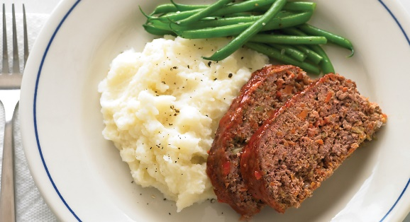

Tickets are required, make checks payable, in advance, to Berkley # 52 OES

When: June 20, 2026
Where: 2216 Old Greenbrier Road Chesapeake, VA 23325
Time: 4:30 PM-6:30 PM
Cost: $15.00/person/meal

Eat In or Take Out
RSVP: Linda Mason @757-285-2147
Call, text, or email: lgmason51@yahoo.com
Or any Berkley #52 OES officer
No Tickets w ill be sold at the door
Meatloaf, mashed potatoes, gravy, green beans, roll and dessert are included
Berkley #52 OES
Meatloaf Dinner

