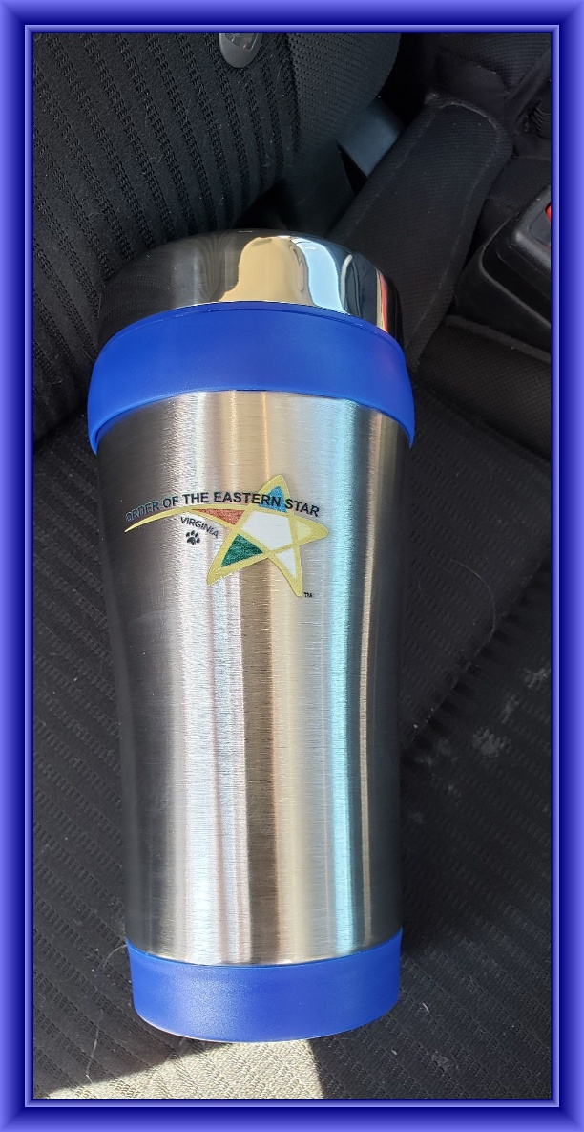
TRIENNIAL COMMITTEE 2024-2027
The Triennial Committee is offering engraved Travel Mugs for a $15 donation.
Reserve yours before they’re gone. To save on shipping, mugs can be picked up at WGM-WGP Homecoming in November or Grand Chapter. Send $15 to Brenda Jones, 335 Plantation Drive, Richlands, VA 24641.

