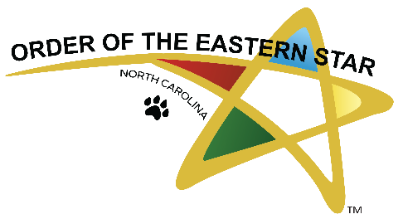

**You Are Invited!**

**The Grand Chapter of North Carolina cordially invites**

**the Grand Chapter of Virginia to an Exchange Visit**

**Friday February 28, 2025 – March 1, 2025**

**Friday, February 28, 2025,** Tour of Wake Forest Regenerative Medical Center

Discover the Wake Forest Regenerative Medical Center! Experience the innovative work at the Wake Forest Institute for Regenerative Medicine (WFIRM), in partnership with the Order of the Eastern Star in North Carolina, dedicated to advancing regenerative medicine.

**Saturday, March 1, 2025,** Moravian Luncheon & Entertainment at the Winston Salem Masonic Center

4537 Country Club Road Winston Salem NC. 27104

Walking tour of Old Salem

**Lodging** Hampton Inn -Winston Salem I-40,

1900 Hampton Court Winston Salem NC 27103   Phone # 336-760-1660

OES Rate $125.00 per night

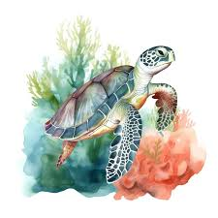

**For Event Coordination**

Sister Debbie is eager to finalize arrangements and needs your headcount for the tour and luncheon at your earliest convenience.

**Debbie Owen, PGM**

910-975-4114

[docardinal@mail.com](mailto:docardinal@mail.com)

PO Box 363 West End NC 27376

**We look forward to seeing you there!**